**\*\* if you transfer Jenkins job to another pc then just add jobs and workspace to corresponding directory and then restart the system.**

**Take care of changing environment variables in** [Configure System](http://localhost:8080/configure), [Configure Global Security](http://localhost:8080/configureSecurity), [Global Tool Configuration](http://localhost:8080/configureTools), as per requirement in various of job steps.

* **Install Jenkins in new server & install all required plugin-30mins**
* **Create a new job named test without any functionality in Jenkins it will create 2 folders in Jenkins directory as workspace and jobs so you need to copy your old workspace and jobs in these corresponding folder-30min.**

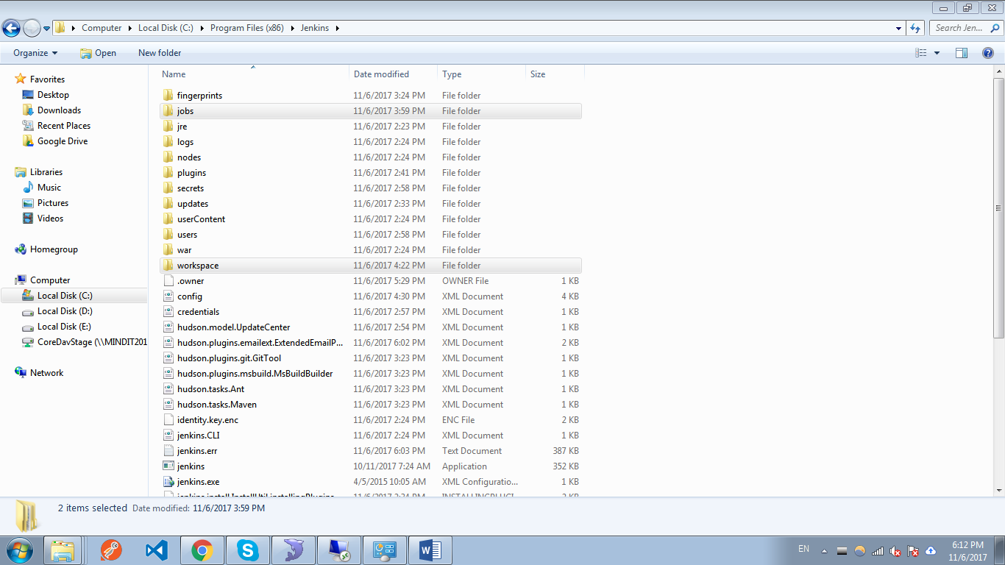

* **change the path variable of git.exe and msbuild.exe and other required exe in in** [Configure System](http://localhost:8080/configure), [Configure Global Security](http://localhost:8080/configureSecurity), [Global Tool Configuration](http://localhost:8080/configureTools) and also in your computer environment variable.-**20mins**
* **change the path which you used inside execute batch commands/jobs –as per project.**
* Please refer [**https://wiki.jenkins.io/display/JENKINS/Administering+Jenkins**](https://wiki.jenkins.io/display/JENKINS/Administering+Jenkins) **for further help;**

**Max total time-2hrs(excluding project error if any).**

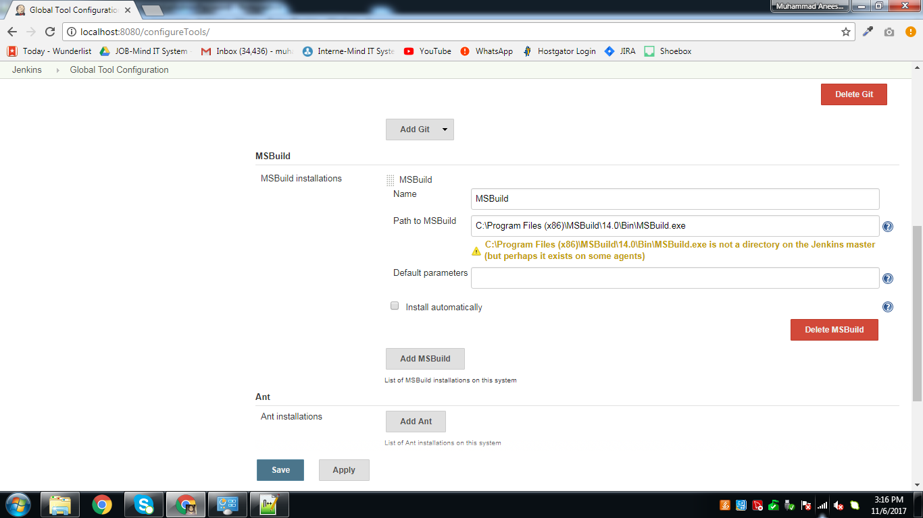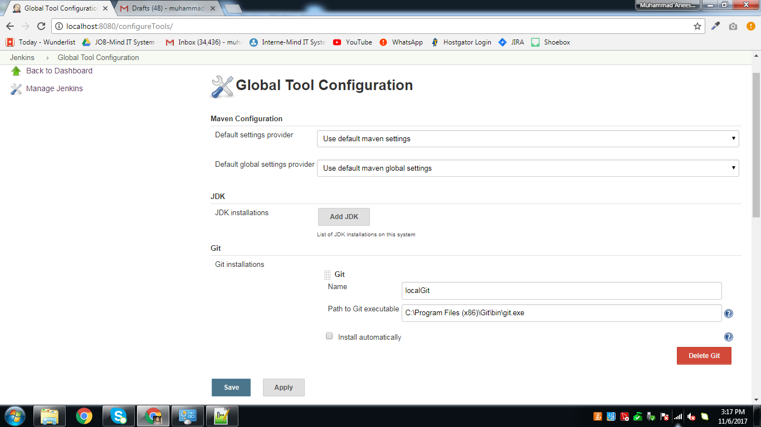

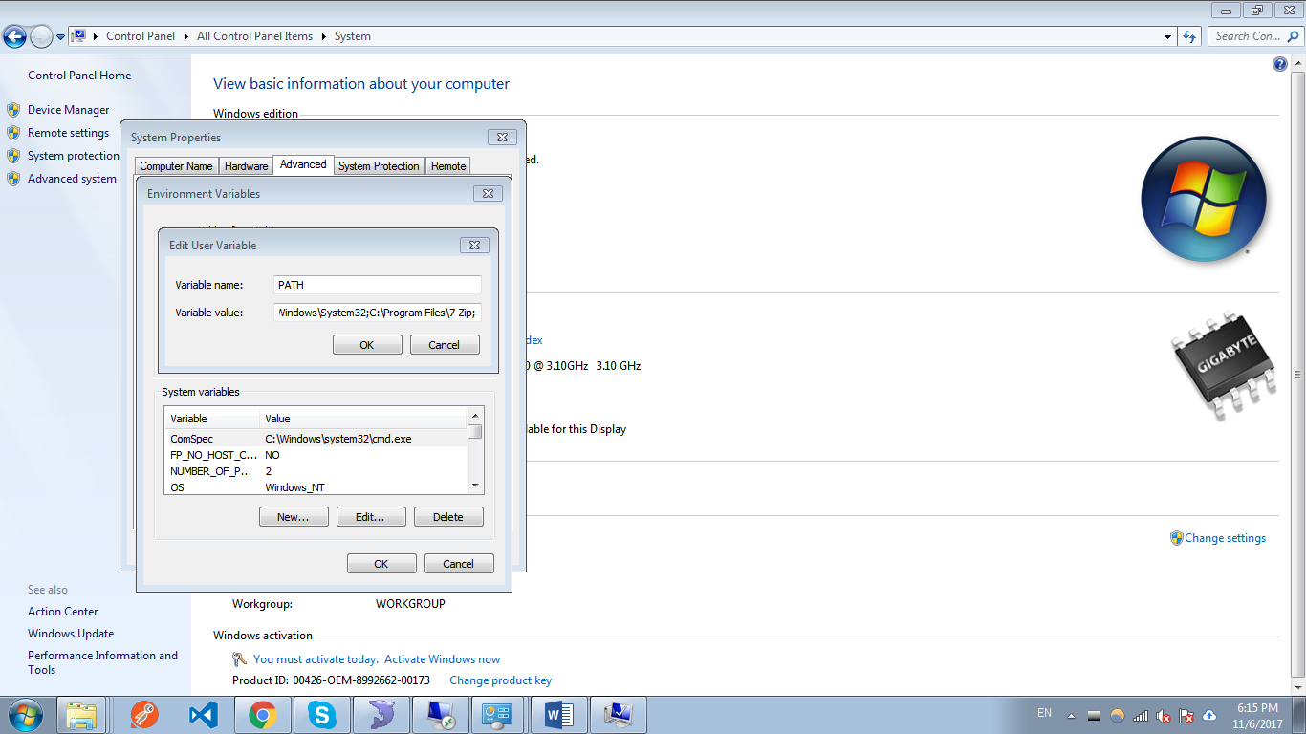

And 